**PBLIF1-4**

**Diet For Beginners**

**1.Use Case Diagram**

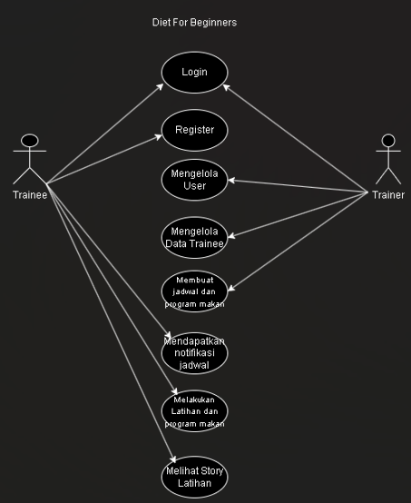

**2. ERD**

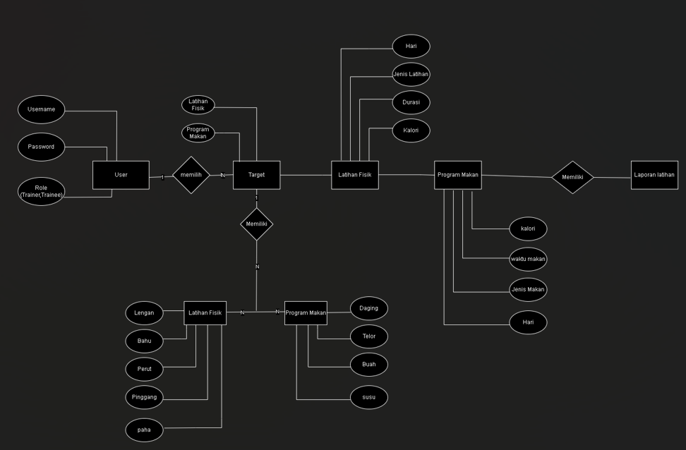

**Nama Anggota kelompok :**

|  |  |
| --- | --- |
| **Rivaldo Franscisco** | 3312401098 |
| **Andre Nataniel Simbolon** | 3312401089 |
| **Marwan Siburian** | 3312401101 |
| **Rafa Adestia Atin** | 3312401091 |
| **Gisella Laudia Perangin-** **Angin** | 3312401109 |